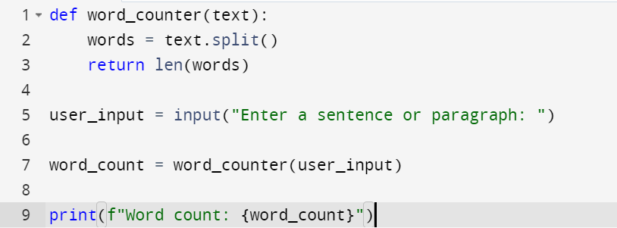

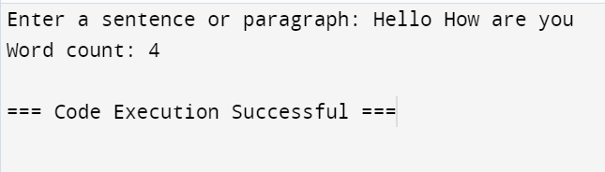

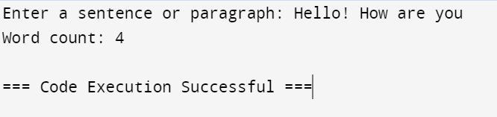

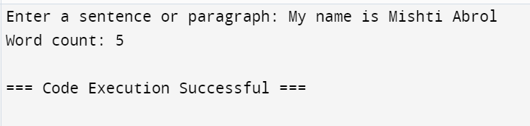

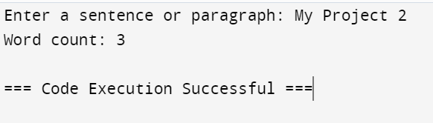

def word_counter(text):

words = text.split()

return len(words)

user_input = input("Enter a sentence or paragraph: ")

word_count = word_counter(user_input)

print(f"Word count: {word_count}")